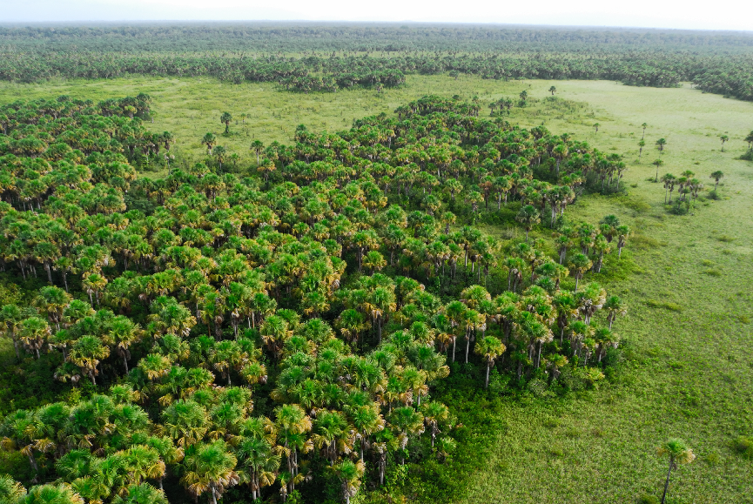
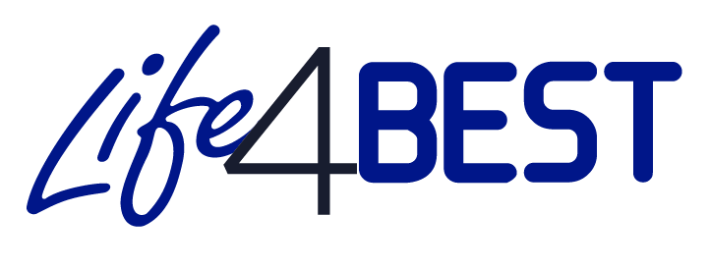
Interim report n° XX
Reporting period: JJ/MM/AAAA to JJ/MM/AAAA
Author: Organization - Name
LIFE4BEST 20XX-XX-XXX
© O. Tostain

Guidelines (to be removed)
*** This section is intended to guide you in preparing your interim report. Please delete it before submitting the final version of your report. ***

Format and content
- Number of pages: 15 pages maximum (without annexes).
- The report must summarise all relevant information to properly present the project’s achievements. It is important to ensure that the information provided is complete and accurate.
- If you have already mentioned a point in one section, please do not duplicate the information in another section, and make a reference to it.
- When describing the achievements, please make sure that you provide all the necessary tangible and verifiable elements (do not hesitate to add supporting documents and pictures in one annex).
- Please include as many annexes as necessary in this report to document achievements, deliverables and communication activities.
- The answer to each question must cover the reference period indicated on page 2.
- Please be sure to customize all fields marked in red.

- Do not forget to update the table of contents.

- Do not forget to inform the logframe and all your indicators including the BEST indicators.

- The information provided below should reflect the financial information contained in the financial report.

In general, in the event that the initially planned project needs to be readjusted (changes in the logical framework: activities, deliverables and milestones, as well as indicators), please contact your regional focal point.

General information

Project title:
Project reference:
Region:
Name of coordinating beneficiary:
Project start date and end date:
Start date and end date of the reporting period:
Total project budget (€):
Names of co-beneficiaries:
Report submission date:
Name of project contact person:
Email address of project contact person:

Self-assessment
Select the status of the project at the end of the period:
☐ Ongoing project - satisfactory implementation of all activities
☐ Delayed project – certain problems had an impact on the implementation of activities
☐ Project at risk - major problems had an impact on the implementation of activities, and call into question the feasibility of the project

Comments

Detail here, in a concise manner, the elements supporting the project status selected in the self-assessment above.

Table of contents

Guidelines (to be removed) 1
General information 2
List of Acronyms and Abbreviations 4
Summary 5
I. Work accomplished by activities 6
II. Deviations or risks identified, and mitigation measures 6
III. Stakeholder engagement 6
IV. Capacity building 6
V. Communication and visibility 7
VI. Environmental and Social Management System (ESMS) 7
ANNEXES 8
Annex 1: Deliverable(s) 8
Annex 2: Photos of activities and results (featuring legend and credits) 8
Annex 3: Copies of communication and visibility activities (publications, articles, etc.) 8

List of Acronyms and Abbreviations

Summary
Give a general overview of project implementation during the reporting period (1 page max.) while referring to your updated logical framework.

- Key achievements:

Describe here the main achievements made during the reporting period compared to the results and activities initially planned. If applicable, describe here as well the additional activities undertaken that were not initially planned.
Describe the specific positive impacts induced by the project at the end of the reporting period.

- Main challenges:

Describe here the challenges, the difficulties you may have encountered in the implementation of your activities during the period.

- Lessons learned:

Describe here the main lessons learned from the implementation of activities during the reporting period.

- Work accomplished by activities

Indicate here the work carried out by all beneficiaries and third parties during the reporting period. Present the progress made in achieving the objectives of the project, while specifying the differences between the work expected under the initial technical description (Annex 1 of the grant agreement) and the work actually carried out.
Logical framework: Be sure to complete your logframe and give her more details on the activities.

- Deviations or risks identified, and mitigation measures
Deviations: Describe here activities that are not fully implemented, critical objectives that are not fully achieved and / or are not progressing as scheduled. Also explain the impact of these deviations on other tasks and the overall project schedule.
Risks: if applicable, indicate here the potential or real risks the project has been facing, and provide details on the foreseen mitigation measures.

- Stakeholder engagement
Describe here the support or involvement of all key stakeholders in your project:
• To what extent have these stakeholders been involved in your project?
How do you assess the relationship with the co-beneficiary (co-beneficiaries)?
With the public authorities where the project is being implemented?
• Highlight any notable achievement, lessons learned, feedback regarding the engagement / participation of the various stakeholders.

- Capacity building

Describe here the capacity building activities and actions deployed during the reporting period, providing:
• Details about the ways in which your project contributed to capacity building within the territory (territories) concerned, the type and purpose (institutional / organizational) of training and support actions (in sustainable financing, human resources management, project management, partnerships, etc.).
• Tangible elements (facts / figures) attesting the capacity building activities directly linked to the project benefiting to organizations or individuals within the territory (territories) or the related region.
- Communication and visibility

Present here the visibility and communication activities of the project within the territory / territories / regions concerned, as well as all the activities and promotion of the project carried out (events, workshops, media, etc.) in order to publicize the project and share its objectives and results, detailing:
• The groups targeted by the various communication actions.
• Supporting documents developed (brochures, flyers, exhibitions, video, website, press articles, etc.), with quantitative details in terms of distribution.
Please add the supporting documents in PDF format in Annex 3 of the report.
Please also specify how the visibility of the contribution of LIFE4BEST and donors is ensured.

- Environmental and Social Management System (ESMS)

Describe here, if applicable, the social and environmental risks related to the project activities and specify the adopted measures to overcome them.
Indicate as well if you foressee other risks in the remaining implementation period?

ANNEXES

Annex 1: Deliverable(s)

Annex 2: Photos of activities and results (featuring legend and credits)

Annex 3: Copies of communication and visibility activities (publications, articles, etc.)

