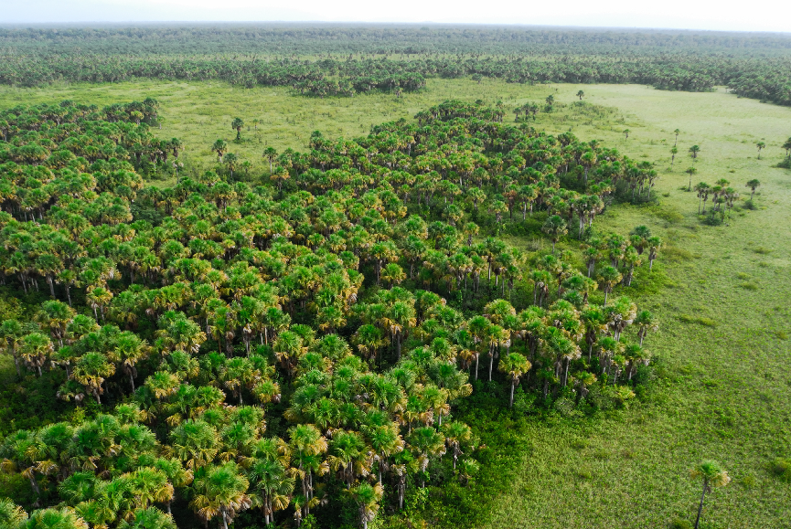
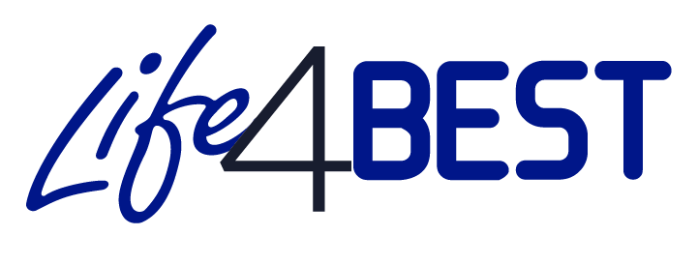
Final Report
Project duration : XX months
Starting date :
Ending date :
Author: Organization - Name
LIFE4BEST 20XX-XX-XXX
© O. Tostain

Guidelines (to be removed)
*** This section is intended to guide you in preparing your final report. Please delete it before submitting the final version of your report. ***

Format and content
- Number of pages: 25 pages maximum (without annexes).
- The report must summarise all relevant information to properly present all the project’s achievements. It is important to ensure that the information provided is complete and accurate.
- If you have already mentioned a point in one section, please do not duplicate the information in another section, and make a reference to it.
- When describing the achievements, please make sure that you provide all the necessary tangible and verifiable elements (do not hesitate to add annexes).
- Please include as many annexes as necessary in this report to document achievements and communication activities.
- The answer to each question must cover the reference period indicated on page 2.
- Please be sure to customize all fields marked in red.

- Do not forget to update the table of contents.

- The information provided below should reflect the financial information contained in the financial report.

General information

Project title:
Project reference:
Region:
Name of coordinating beneficiary:
Project start date and end date:
Total duration: XX months
Total project budget at the end of the project (€):
Names of co-beneficiaries:
Report submission date:
Name of project contact person:
Email address of project contact person:

Table of Contents

Guidelines (to be removed) 1
General information 2
List of Acronyms and Abbreviations 4
I. Project overview 5
II. Achievements in relation to the results and objective of the project 5
IV. Stakeholder engagement 6
V. Capacity building 6
VI. Communication and visibility 6
VII. Sustainability and replication potential 6
VIII. Lessons learned / feedback on experience 7
IX. Additional information 7
ANNEXES 8
Annex 1: Deliverable(s) 8
Annex 2: Photos of activities and results (featuring legend and credits) 8
Annex 3: Copies of communication and visibility activities (publications, articles, etc.) 8

List of Acronyms and Abbreviations

- Project overview

Please provide a brief overview of the project, recalling:
• The location of project activities (include a map, if possible).
• The species, habitats, ecosystems, ecosystem services concerned, etc.
• The issue(s) the project aimed to tackle.
• The project’s approach to address the issue(s).
• What the project aimed to achieve.
- Achievements in relation to the results and objective of the project
Please explain whether the project achieved all the objective and expected results (as presented in the logical framework submitted in your proposal).
If not, explain why in detail.

In this section, be sure to:
• Highlight any concrete impact that the project has achieved in terms of biodiversity conservation / sustainable use of natural resources / adaptation and mitigation to climate change / ecosystem services.
• Highlight any achievement in terms of local development (i.e. economic and social benefits).

Also assess whether the project has induced unintended positive results.

- Work accomplished by project activities

Describe the work carried out for each of the activities planned in your project, indicating:
• Any activity that could not be carried out.
• All the results of the actions.
• Any change in the approach to the project compared to what was initially planned.
• Any problem encountered (delay, cancellation of activities, etc.) and the mitigation measures undertaken, if necessary.
Logical Framework: be sure to include the reporting information related to your logical framework provide rationale and details on your indicators.
DO NOT FORGET TO ADD YOUR FINAL UPDATED LOGFRAME highlighting the BEST indicators results

- Stakeholder engagement
Describe the support or involvement of all key stakeholders in your project:
• To what extent have these stakeholders been involved in your project?
How do you assess the relationship with the co-beneficiary (co-beneficiaries)?
With the public authorities where the project was implemented?
• Highlight any notable achievement, lessons learned, experience feedback with regard to said engagement / participation of the various stakeholders.

ADD TANGIBLE FACTS AND FIGURES

- Capacity building

Describe here the capacity building activities and actions deployed during the project, providing:
• Details about the ways in which your project contributed to capacity building within the territory (territories) concerned, the type and purpose (institutional / organizational) of training and support actions (in sustainable financing, human resources management, project management, partnerships, etc.).
• Tangible elements (facts / figures) attesting to capacity building directly linked to the project and benefiting to organizations or individuals within the territory (territories) or the related region.

- Communication and visibility

Present here all the visibility and communication activities of the project within the territory / territories / regions concerned, as well as all the activities and promotion of the project carried out (events, workshops, media, etc.) in order to publicize the project and share its objectives and results, detailing:
• The groups targeted by the various communication actions (add figures).
• Supporting documents developed (brochures, flyers, exhibitions, video, website, press articles, etc.), with quantitative details in terms of distribution.
Please add the supporting documents in PDF format in Annex 3 of the report.
Please also specify how the visibility of the contribution of LIFE4BEST and donors has been ensured.

- Sustainability and replication potential

• Explain how the results and achievements of the project will be continued beyond the lifetime of the project and the LIFE4BEST programme.
• Indicate any activity that will be continued beyond the project and the LIFE4BEST programme.
• Describe the long-term benefits and effects of the project, and provide an estimate of the potential for replicability and transfer of knowledge and experience gained during the project.
- Lessons learned / feedback on experience

This section concerns lessons learned and feedback from all points of view including administrative, technical, financial, and management, for example:
• What went well and what did not go well at all during your project?
• If you had to do again your project, what would you do differently?
• What would your advice and recommendations be if others wanted to implement a similar project?
• How will you capitalize on these lessons learned in your future activities?

- Additional information

Please include here any additional information / comments useful for the reporting on your project, which has not already been mentioned in this report.
If you think your project is a successful story how would you define it?

ANNEXES

Annex 1: Deliverable(s)

Annex 2: Photos of activities and results (featuring legend and credits)

Annex 3: Copies of communication and visibility activities (publications, articles, etc.)

ATTENTION: Any substantial change must have been notified to the LIFE4BEST Secretariat and to your LIFE4BEST regional focal in the form of a grant agreement amendment request. The request is subject to approval by the Secretariat. Too late information on substantial changes won’t be accepted and will prevent report validation.

