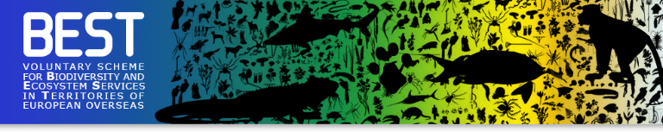
- Call for proposals 2020 –
FULL PROPOSAL
Proposal Reference:  Complete with the reference available from the portal. | 2020-
1. Relevance and effectiveness
1.1 LIFE4BEST objectives
Explain how the project objective will concretely contribute to the main and complementary BEST objective(s). Maximum 300 words
1.2 Expected results and impacts
Highlight tangible expected impacts during the lifetime of the project; ensure that expected results are defined using the SMART approach: Specific, Measurable, Achievable, Realistic and Timely. Maximum 300 words
1.3 Political relevance
Highlight in a concise manner the relevance of the project with the BEST regional ecosystem profiles and Investment Strategies (when available), Key Biodiversity Areas and with the national and local policies and strategies, as well as with the European Strategy for the Outermost regions. Maximum 200 words
2. Design and methodology
2.1 Activities
Present, list and detail the activities and their relevance to reach the expected results. Present also the feasibility, in line with budget and timeline. Maximum 400 words
Expected result 1:
Activity 1.1:
Activity 1.2:
Activity 1.3:
Expected result 2:
Activity 2.1:
Activity 2.2:
Activity 2.3:
Expected result 3:
Activity 3.1:
Activity 3.2:
Activity 3.3:
[Add further lines when necessary]

2.2 Project schedule
Complete the planning of activities below
Month | 1 | 2 | 3 | 4 | 5 | 6 | 7 | 8 | 9 | 10 | 11 | 12 | 13 | 14
Expected Result 1
Activity 1.1 example
Activity 1.2 example
Activity 1.3 example
Expected Result 2
Activity 2.1
Activity 2.2
Activity 2.3
Expected Result 3
Activity 3.1
Activity 3.2
Activity 3.3
[Add further lines when necessary]

2.3 Risks
List below the risks linked to the project as well as their probabilities of occurrence, impact level and mitigation actions.
Risk description | Probability of Occurrence  (H/M/L)* | Impact on the project  (H/M/L)* | Mitigation action(s)
[Add further lines when necessary]
* High/Medium/Low
2.4 Logical Framework
To be filled in online
2.5 Legal framework
Precise if you have all necessary authorisation to implement the activities in line with local, national and international regulations; in particular if you are working with protected species, collecting any biomaterial (such as seeds) or if commercial benefits are expected. Enclose the relevant authorisations. Maximum 200 words
3. Partnership and synergies
3.1 Stakeholders
Present the stakeholders involved, their roles, activities and expected contribution with the modalities of collaboration during the project implementation. Maximum 300 words
3.2 Capacity building and local partnership(s)
Describe how the project will contribute to local capacity building, to share experiences and develop collaborations.Maximum 200 words
3.3 Cooperation, synergy intra/inter-territorial
Describe the synergies and complementarities with other projects in the same region or any other OCTs, ORs, or ACP countries, in particular with the ones benefiting from a European support (such as BEST2.0+ or BIOPAMA) that will contribute to territorial cooperation, coherence or the global reach. Maximum 200 words
4. Budget
Complete the budget using the template available and upload it online
5. Added value and sustainability
5.1 Sustainability and replicability
Describe how the project will maintain its benefits after the project has been completed and the envisaged replicability measures.
Maximum 200 words
5.2 Communication and visibility
List the communication and dissemination activities that will be implemented: How will the project engage with the targeted audience(s)? What are the key messages? What are the expected results? Maximum 300 words
5.3 Gender equality and equal opportunities
Highlight how the project will take into account gender equality and equal opportunities, the needs and rights of people with disabilities, youth, minorities and indigenous peoples. Maximum 200 words

Name of the authorised representative: ______________________
Function: ____________________
Date: _______________________
Signature: ___________________
(Organisation Stamp)

