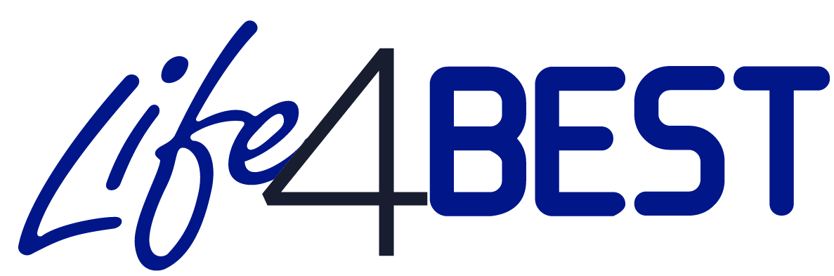
- Call for proposals 2020 –
CO-APPLICANT MANDATE
The co-applicant authorises the Applicant <insert the name of the lead applicant organisation> to submit on their behalf the present application form and to sign the standard grant contract with IUCN as well as, to be represented by the Applicant in all matters concerning this grant contract.
I have read and approved the contents of the proposal submitted to IUCN. I undertake to comply with the principles of good partnership practice.

Name: ______________________
Function: ____________________
Date: _______________________
Signature : ___________________ (Organisation Stamp)

